**Experiment 2.1**

**Student Name: Yash Gupta UID: 20BCS5009**

**Branch: BE-CSE Section/Group:20BCS_DM-716 B**

**Semester: 6 Date of Performance: 13/03/23**

**Subject Name: IOT LAB Subject Code: 20CSP_358**

1. **Aim:**

Demonstration of the working of Ultrasonic sensor using Arduino board.

1. **Objective:** 
   * Learn about IoT based simulations.
   * Learning the circuitry.

1. **Code-Output:** 
   * Hardware Requirement

o Arduino Uno

o Ultrasonic

* 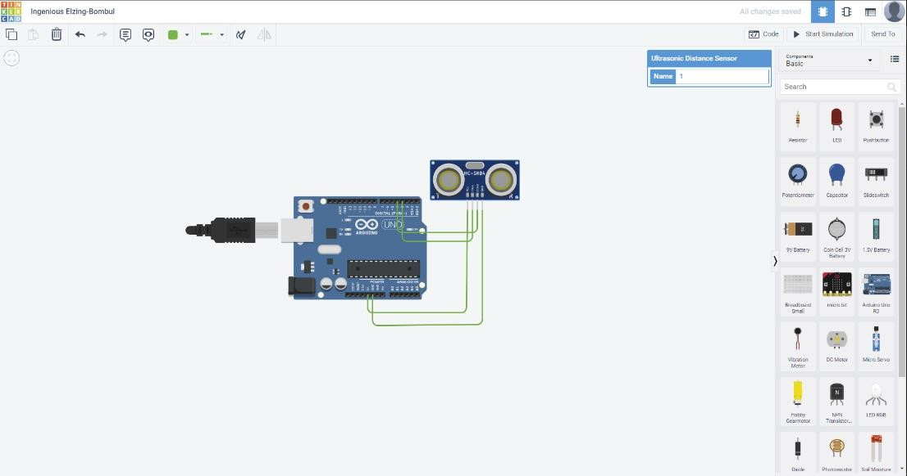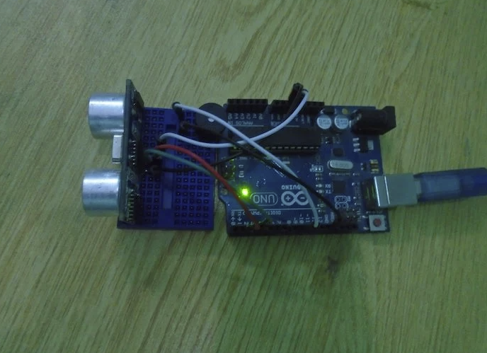Circuitry

#define echo_pin 4

#define trig_pin 3

long duration_0;

int distance_0;

void setup () {

pinMode (trig_pin, OUTPUT);

pinMode (echo_pin, INPUT);

Serial.begin (9600);

Serial.println("ultrasonic distance fin...");

}

void loop() {

digitalWrite (trig_pin, LOW);

delayMicroseconds (2);

digitalWrite (trig_pin, HIGH);

delayMicroseconds (10) ;

digitalWrite (trig_pin, LOW);

duration_0 = pulseIn (echo_pin, HIGH);

distance_0 = duration_0+ 0.034 / 2;

Serial.print ("distance: ");

Serial.print (distance_0);

Serial.println(" cm");

}

**OUTPUT : -**

